34.87: Below, x is the distance from object to the screen’s original position.
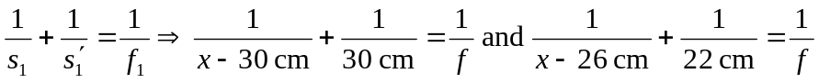
But the object must be to the left of the lens, so . The corresponding focal length is 10.56 cm.

